Project report

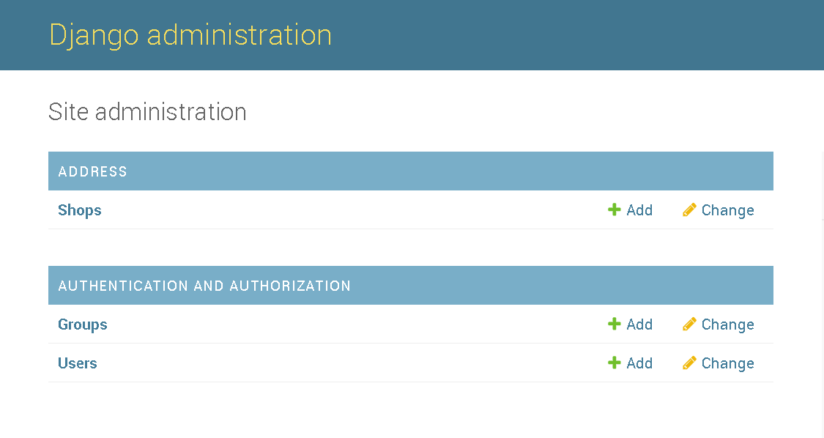

This is my ajango admin page.

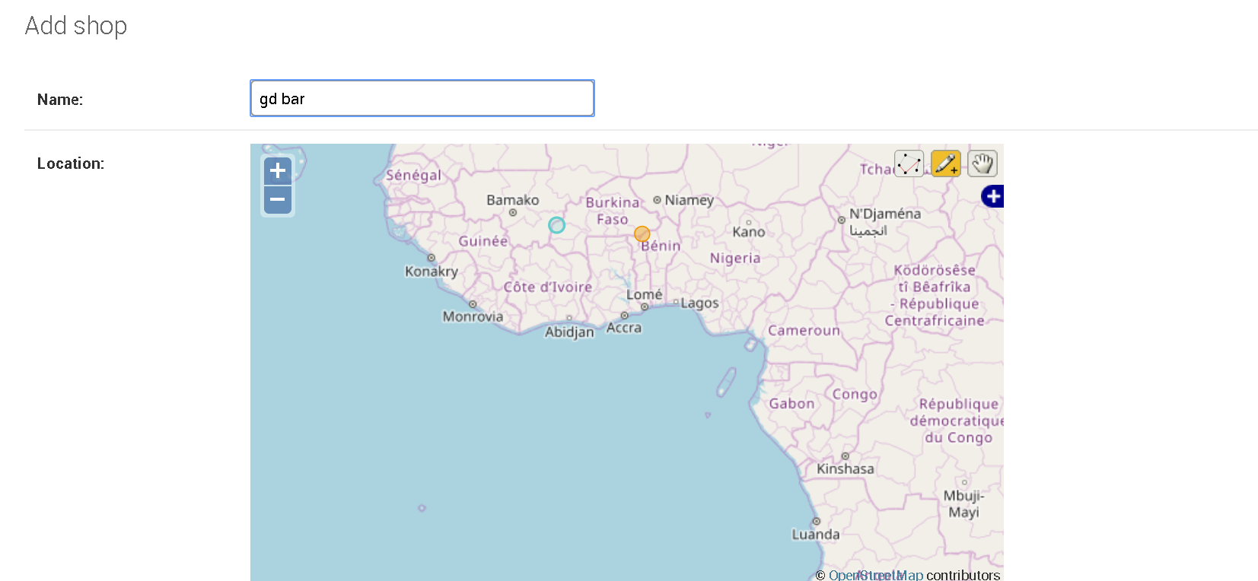

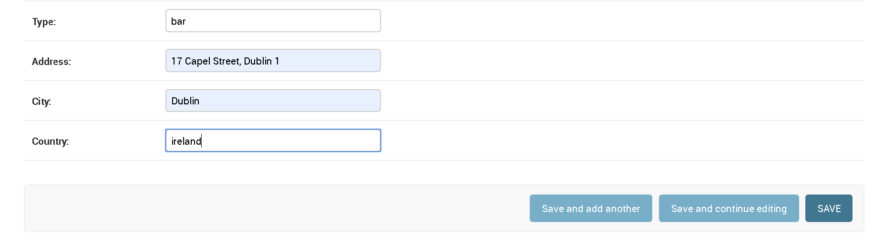

This is add data into postgresql

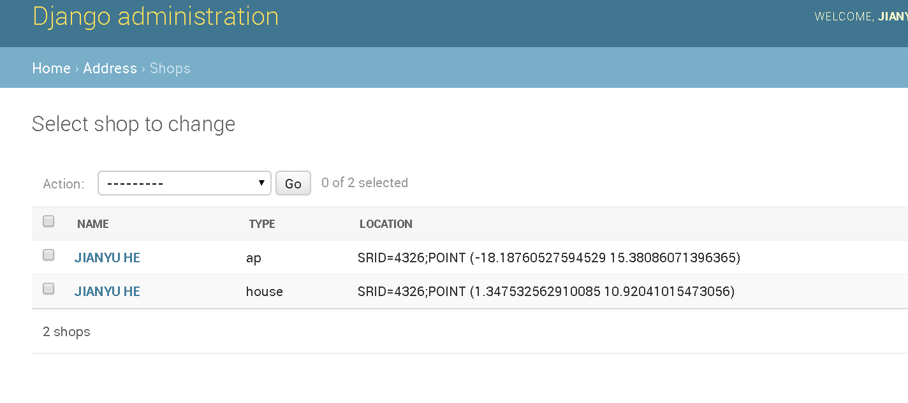

Show data.

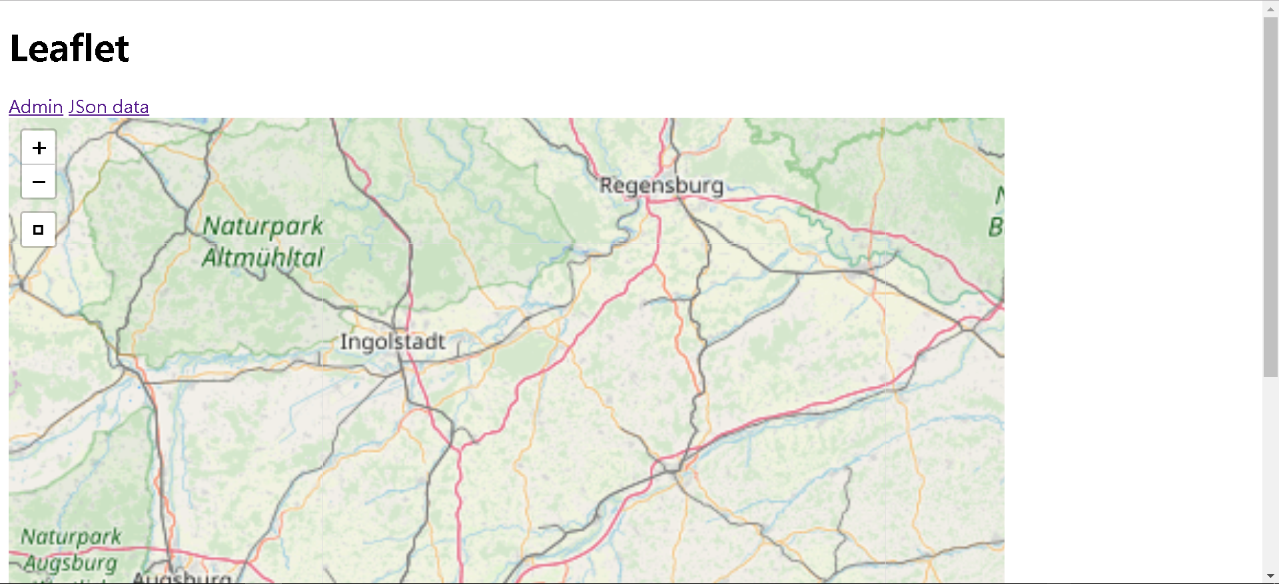

Show leaflet map, for my idea is to take location from geodjango in to leaflet, but I my code is not work as below:

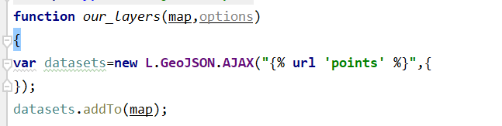

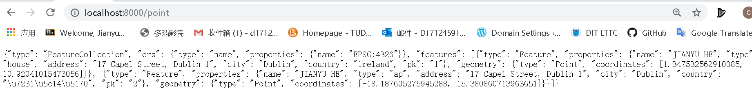

But I can print data on the web.

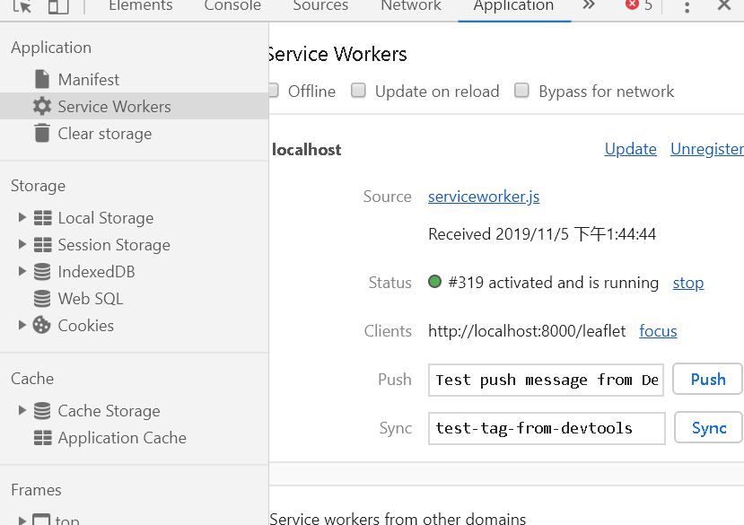

The service workers of pwa is work for web page.

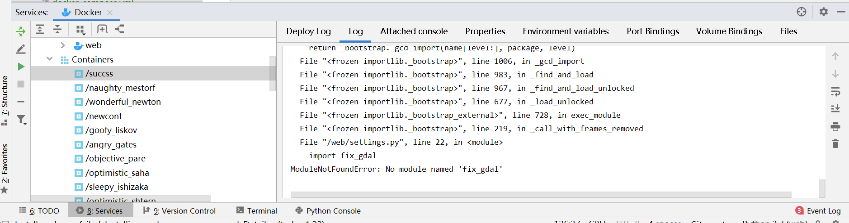

I try to create docker image, but have error I so hard to solve.